Form No. 40-265: For Reporting Year (RY) 2024
Network Service Area Report Tab
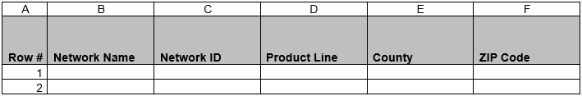
Summary of Changes:
No changes to the RY 2024 Network Service Area Report Tab fields.

Form No. 40-265: For Reporting Year (RY) 2024
Enrollment Report Tab
Summary of Changes:
No changes to the RY 2024 Enrollment Report Tab fields.

