Form No. 40-260: For Reporting Year (RY) 2025
Raw Data – NPMH Report Tab
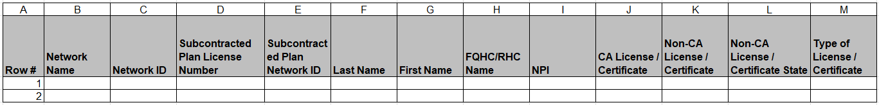
Continuation:
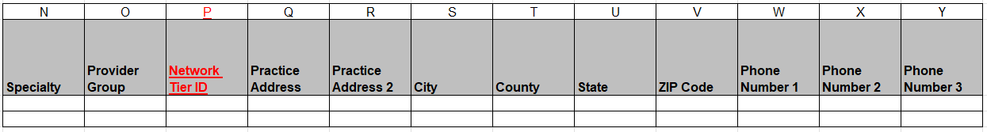
Continuation:
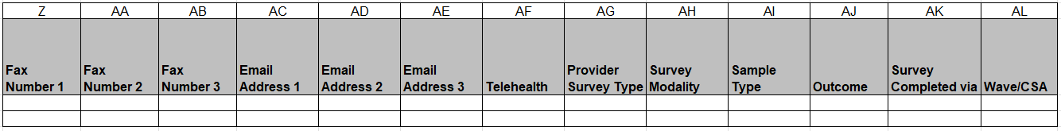
Continuation:
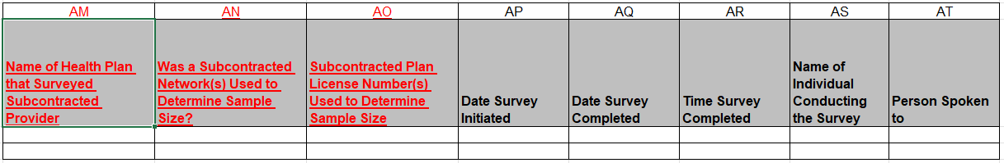
Continuation:
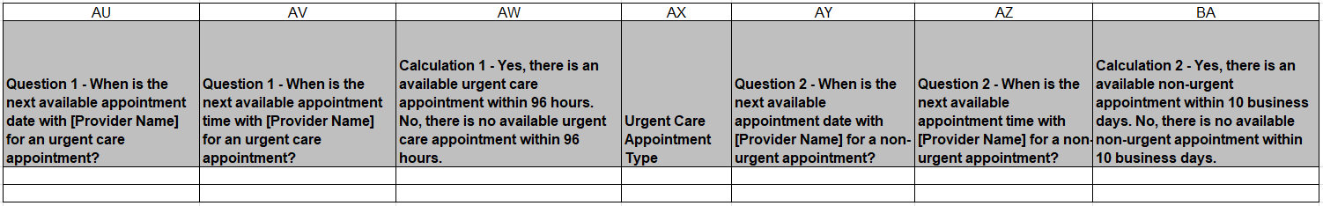
Continuation:
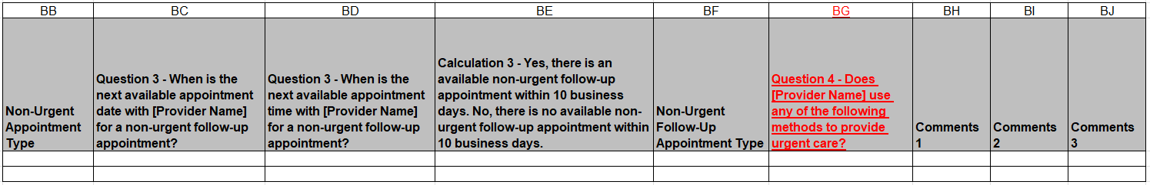
Summary of Changes:
Raw Data – NPMH Report Tab
Excel Column Reference | RY 2025 TA Report Form Heading | Action
P | Network Tier ID | Added Field and Field Instructions
Q | Practice Address | Updated Field Instructions
AM | Name of Health Plan that Surveyed Subcontracted Provider | Added Field and Field Instructions
AN | Was a Subcontracted Network(s) Used to Determine Sample Size? | Added Field and Field Instructions
AO | Subcontracted Plan License Number(s) Used to Determine Sample Size | Added Field and Field Instructions
AX | Urgent Care Appointment Type | Updated Field Instructions
BB | Non-Urgent Appointment Type | Updated Field Instructions
BF | Non-Urgent Follow-Up Appointment Type | Updated Field Instructions
BG | Question 4 – Does [Provider Name] use any of the following methods to provide urgent care? | Added Field and Field Instructions

