Form No. 40-264: For Reporting Year (RY) 2025
Results – PCP Tab
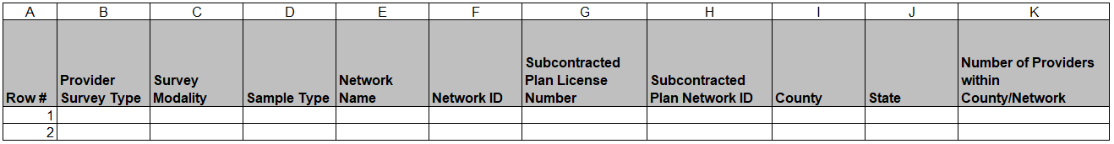
Continuation:
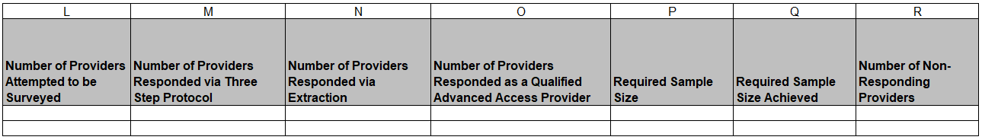
Continuation:
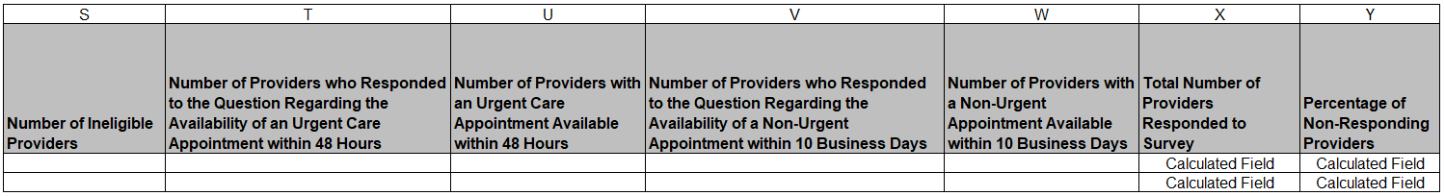
Continuation:
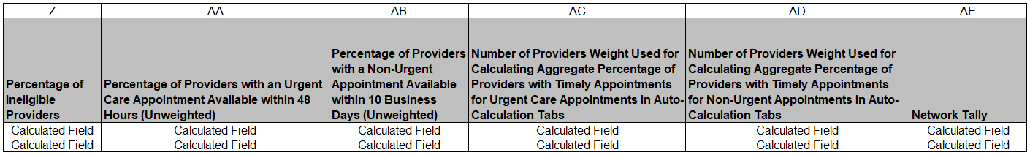
Summary of Changes:
Results – PCP Tab
Excel Column and Tab Reference | RY 2025 TA Report Form Heading | Action
G Results - PCP | Subcontracted Plan License Number | Updated Field Instructions
H Results - PCP | Subcontracted Plan Network ID | Updated Field Instructions

Form No. 40-264: For Reporting Year (RY) 2025
Results – NPMH Tab
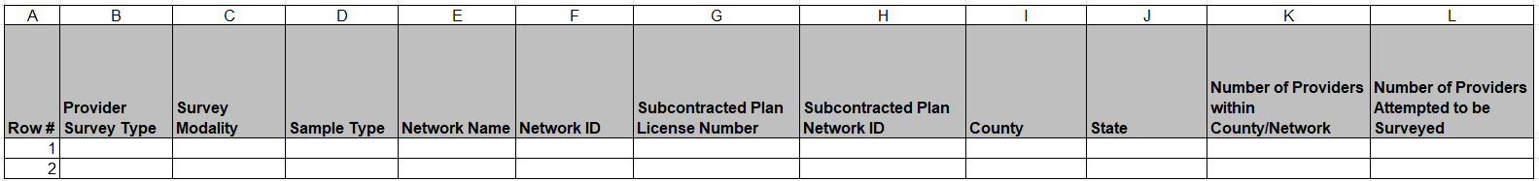
Continuation:
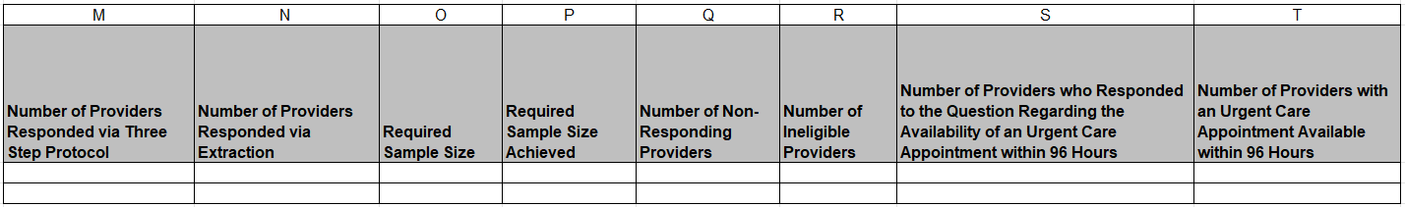
Continuation:
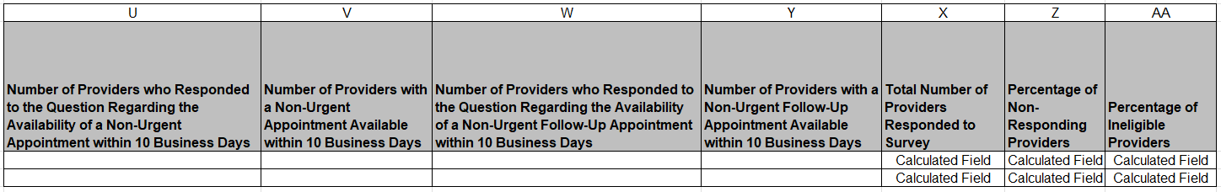
Continuation:
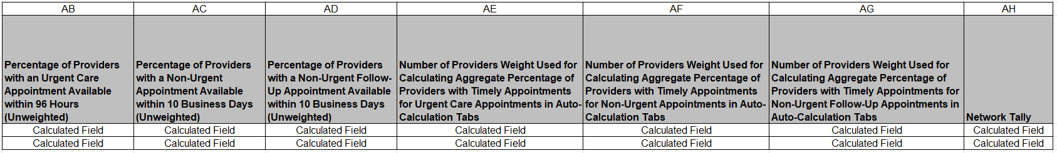
Summary of Changes:
Results – NPMH Tab
Excel Column and Tab Reference | RY 2025 TA Report Form Heading | Action
G Results – NPHM | Subcontracted Plan License Number | Updated Field Instructions
H Results – NPMH | Subcontracted Plan Network ID | Updated Field Instructions

Form No. 40-264: For Reporting Year (RY) 2025
Results - Specialist Physician Tab
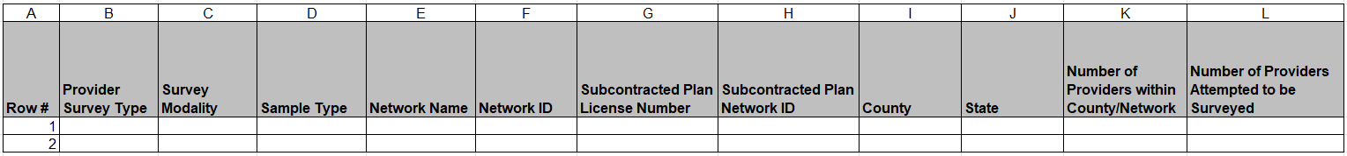
Continuation:
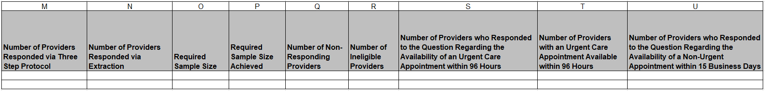
Continuation:
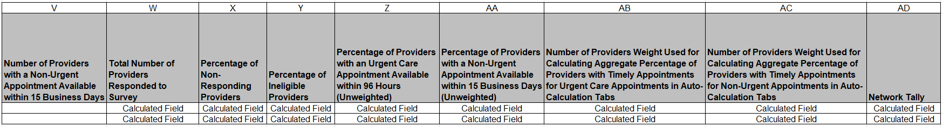
Summary of Changes:
Results - Specialist Physician Tab
Excel Column and Tab Reference | RY 2025 TA Report Form Heading | Action
G Results – Specialist Physician | Subcontracted Plan License Number | Updated Field Instructions
H Results – Specialist Physician | Subcontracted Plan Network ID | Updated Field Instructions

Form No. 40-264: For Reporting Year (RY) 2025
Results – Psychiatrist Tab
Continuation:
Continuation:
Summary of Changes:
Results – Psychiatrist Tab
Excel Column and Tab Reference | RY 2025 TA Report Form Heading | Action
G Results – Psychiatrist | Subcontracted Plan License Number | Updated Field Instructions
H Results – Psychiatrist | Subcontracted Plan Network ID | Updated Field Instructions

Form No. 40-264: For Reporting Year (RY) 2025
Results – Ancillary Tab
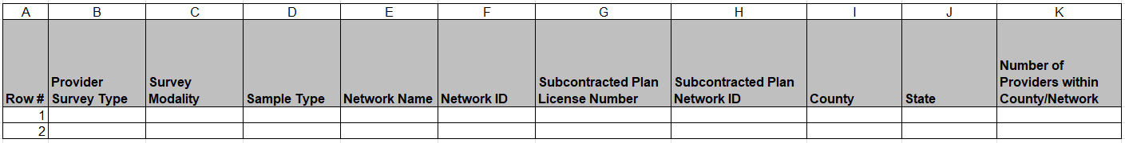
Continuation:
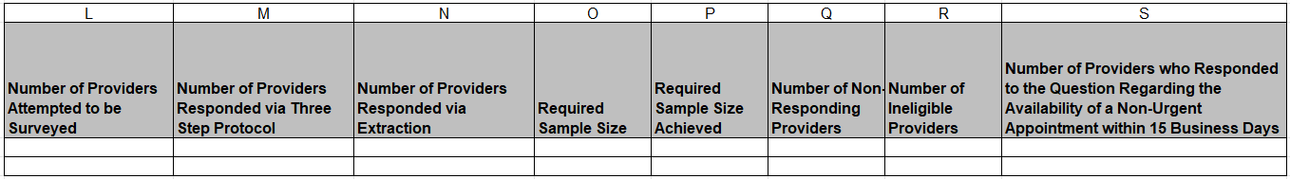
Continuation:
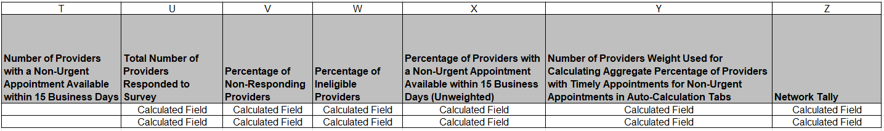
Summary of Changes:
Results – Ancillary Tab
Excel Column and Tab Reference | RY 2025 TA Report Form Heading | Action
G Results – Ancillary | Subcontracted Plan License Number | Updated Field Instructions
H Results – Ancillary | Subcontracted Plan Network ID | Updated Field Instructions

Form No. 40-264: For Reporting Year (RY) 2025
Results – Summary of Rates of Compliance Tab
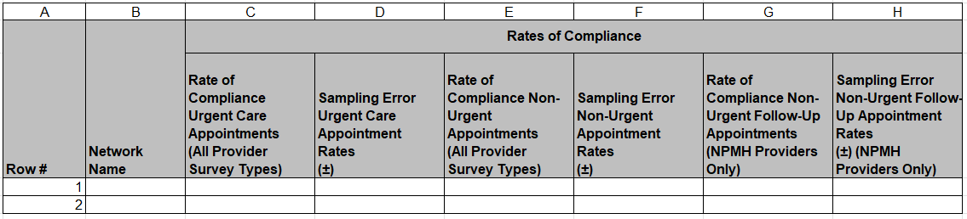
Continuation:
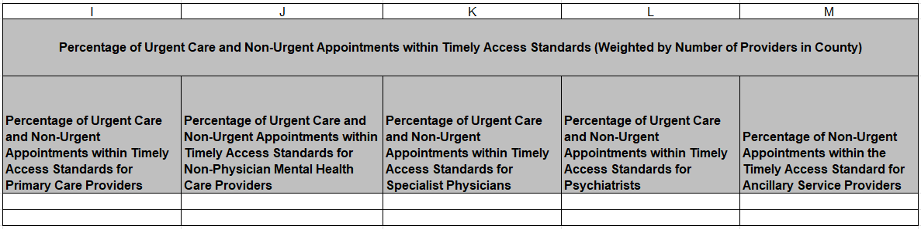
Summary of Changes:
Results – Summary of Rates of Compliance Tab
No Changes.

Form No. 40-264: For Reporting Year (RY) 2025
Results – Network by Provider Survey Type Tab
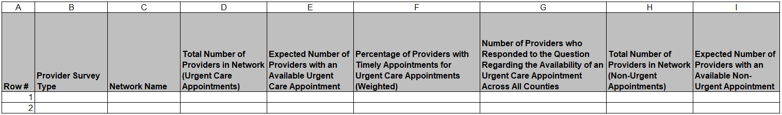
Continuation:
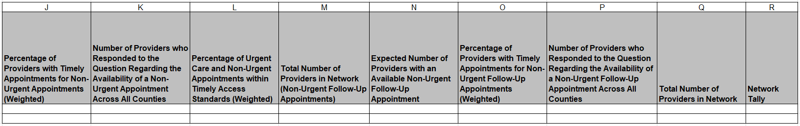
Summary of Changes:
Results – Network by Provider Survey Type Tab
No Changes.

