Form No. 40-268: For Reporting Year (RY) 2024
Mental Health Professional Report Tab
Continuation:
Continuation:
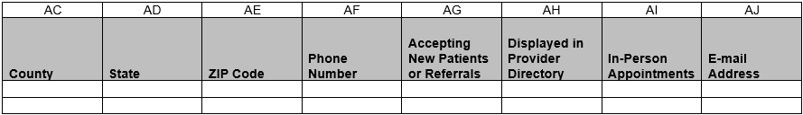
Summary of Changes:
Mental Health Professional Report Tab
Excel Column Reference | RY 2024 ANR Report Form Heading | Action
I | Entity Name | Added Field and Field Instructions
J | Entity NPI | Added Field and Field Instructions
Q | Clinical Encounters by Network Provider | Updated Field Instructions
R | Number of Enrollees Utilizing the Network Provider | Updated Field Instructions
S | Network Tier ID | Updated Field Instructions
AG | Accepting New Patients or Referrals | Updated Field Instructions
AI | In-Person Appointments | Updated Field Instructions

Form No. 40-268: For Reporting Year (RY) 2024
Mental Health Facility Report Tab
Continuation:
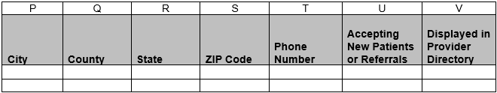
Summary of Changes:
Mental Health Facility Report Tab
Excel Column Reference | RY 2024 ANR Report Form Heading | Action
M | Network Tier ID | Updated Field Instructions

