Form No. 40-258: For Reporting Year (RY) 2025
Contact List – Ancillary Report Tab
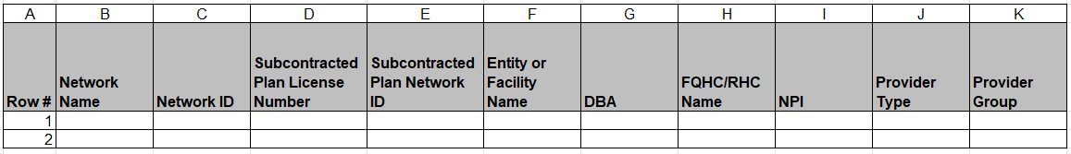
Continuation:
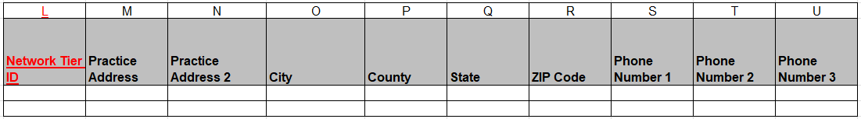
Continuation:
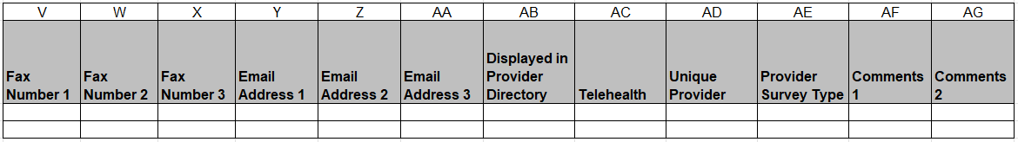

Summary of Changes:
Contact List – Ancillary Report Tab
Excel Column Reference | RY 2025 TA Report Form Heading | Action
L | Network Tier ID | Added Field and Field Instructions
M | Practice Address | Updated Field Instructions

